Work Jerks:

How to Cope with Difficult Bosses and Colleagues

By Louise Carnachan

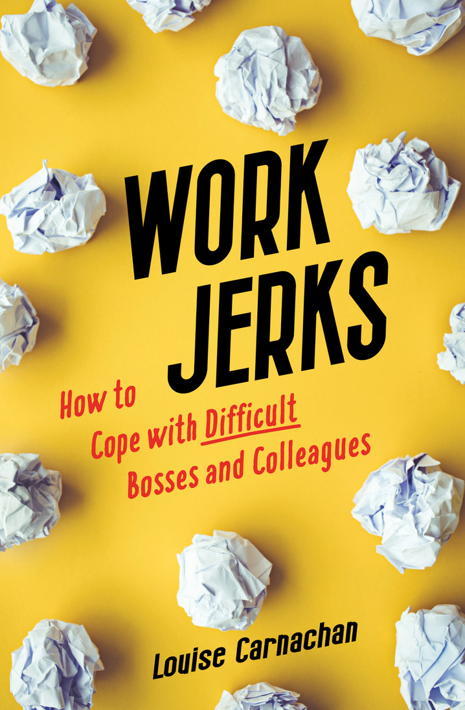

Book Summary
If you’re frequently stressed and unhappy because of problems with a boss or colleague, you end up paying a price. Not only can your mental and physical health suffer, your nearest and dearest get sick of hearing about it. Going to bed angry and waking up dreading a new workday is a terrible way to live. Work Jerks provides practical advice to improve challenging work relationships. Suggestions are provided to tailor actions to your specific and unique situation. Whether the job is in-person or remote, help is here!

Book Details

Published: ‎ June 14, 2022

Language‏: ‎ English

Paperback‏: ‎ 256 pages

ISBN-10‏: ‎ 1647423694

ISBN-13‏: ‎ 978-1647423698
Available for preorder: Amazon, Barnes & Noble, Target, Walmart
After June 14, 2022, available wherever books are sold
Categories: BUSINESS | LEADERSHIP, MANAGEMENT & COMMUNICATION | MOTIVATIONAL & PERSONAL SUCCESS

In Praise of Louise Carnachan

“Eye-opening, insightful, and filled with practical advice about office jerks.” Kirkus Reviews
Full Kirkus Review: https://www.kirkusreviews.com/book-reviews/louise-carnachan/work-jerks/

“This book is a lifesaver!” —Laurie Miyauchi, Senior HR Manager, Microsoft

“I LOVE this book! Brilliant! Carnachan nailed it into something that’s easy to read, assimilate, and apply to all aspects of life, not just work. I wish I’d read it years ago.”—Victoria Evans, Washington State Director of Behavioral Health, Molina Healthcare

"I urge you to throw any reservations to the wind and begin transforming your attitude and behavior toward workplace “jerks.” Work Jerks is theoretically sound and that’s important. But it’s also a most practical book on dealing, effectively, with troublesome people in the workplace. I highly recommend it!” —Norm Stamper, Ph.D., Breaking Rank: A Top Cop’s Exposé of the Dark Side of American Policing and To Protect and Serve: How to Fix America’s Police

“The perfect combination: excellent advice for tackling real work issues while simultaneously making you laugh out loud.” —Kerry McMillan, Acting Director, Supportive Care, Seattle Cancer Care Alliance

“The in-the-trenches approach on workplace culture touches real experience and emotion…readers will not only relate to the stories but find solutions.”—Michael D. Page, AuD.

“If you are struggling with a relationship at work, this is a great place to start formulating your strategy for handling it. If you ARE the 'difficult relationship at work,' this is a great place to begin your own best self-examination. In either case, Louise Carnachan's crisp writing, deep experience and cogent advice offer a strong foundation for practical action and insightful personal growth.”—Daniel K Oestreich, leadership coach and consultant, co-author of Driving Fear Out of the Workplace and The Courageous Messenger

About the Author

Louise Carnachan, MSW, has helped thousands of leaders and staff members achieve interpersonal success in work relationships. As an instructor, coach, and organization development consultant, her employers and clients have ranged from large Fortune 500 companies to small nonprofits. Along with her credentials, Louise has firsthand experience being an employee who has dealt with the nuances of organizational politics. She pens a workplace advice blog (with debatable input from her feline officemates) from a suburb of Portland, Oregon.
www.LouiseCarnachan.com
www.faccebook.com/lacarnachan/
www.linkedin.com/in/louise-carnachan

Publishing and Media

Publicity Contact: Krista Rolfzen Soukup, Blue Cottage Agency, www.BlueCottageAgency.com
Krista@bluecottageagency.com

Publisher: She Writes Press www.shewritespress.com

Sample Press Release

Practical Advice for Dealing with Difficult Coworkers

DATE-TOWN-STATE- Author Louise Carnachan will (SPEAK<SIGN COPIES) of her newly released book Work Jerks: How to Cope with Difficult Bosses and Colleagues (She Writes Press, 2022) on (DAY, DATE, TIME) at (LOCATION). Carnachan is an organizational development consultant and leadership coach who has taken her career’s worth of experience to provide insights and sage advice on handling problematic relationships at work.

“Eye-opening, insightful, and filled with practical advice about office jerks.” Kirkus Reviews

“If people behaved well at work, I never would have had a career,” Carnachan says with a chuckle. Her counsel is rooted in her degrees in psychology and social work as well as the school of hard knocks. “It’s one thing to have an academic understanding of people and group dynamics, it’s another to go to work every day and cope in the trenches. What I’ve learned in my own employment as well as in coaching clients, all the advice in the world won’t help unless it’s something you believe you can implement while not making things worse—especially if you want to keep your job.” Carnachan’s jobs ran the gamut from ironing cowboy shirts to being a motel maid, dishwasher, waitress and salesclerk before moving into more professional positions. “It doesn’t matter where you work or what job you have, jerks have a habit of showing up just about everywhere,” she says.

Carnachan currently coaches a select group of leadership clients and writes a work advice blog from her home in a suburb of Portland, Oregon. You can follow her at www.LouiseCarnachan.com. She’s a proud member of the Chrysalis Women’s Writers at Clackamas Community College.

Author Representation by

Krista Rolfzen Soukup, Literary Agent & Publicist
Blue Cottage Agency
218-828-4717
Representing and Promoting Literary Arts
www.BlueCottageAgency.com

